

Lab Manual
Subject: Programming of AI

By
M Zubair khan 2023-BS-AI-141
Semester 5th
Course Code AI-212
Supervised by Sir Samraiz
The University of Faisalabad
Bachelors of Science in Artificial Intelligence
DEPARTMENT OF COMPUTER SCIENCE

Lab 1
Q1. Banking Transaction Validator with PIN
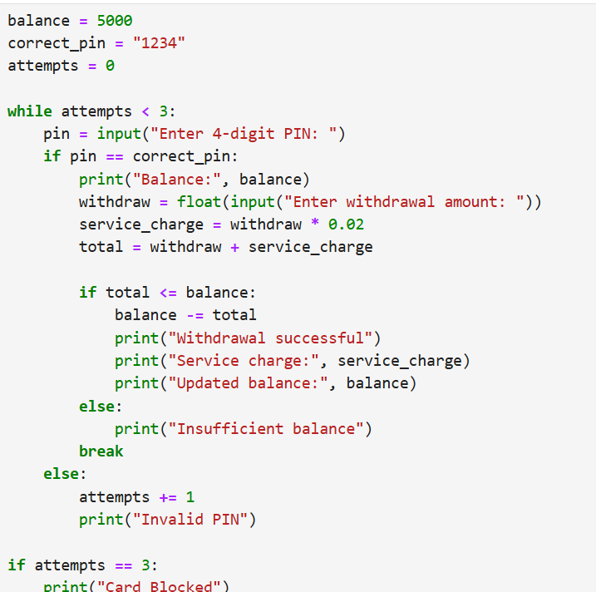
Output:
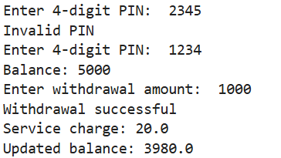
Q2. Grocery Store Inventory System
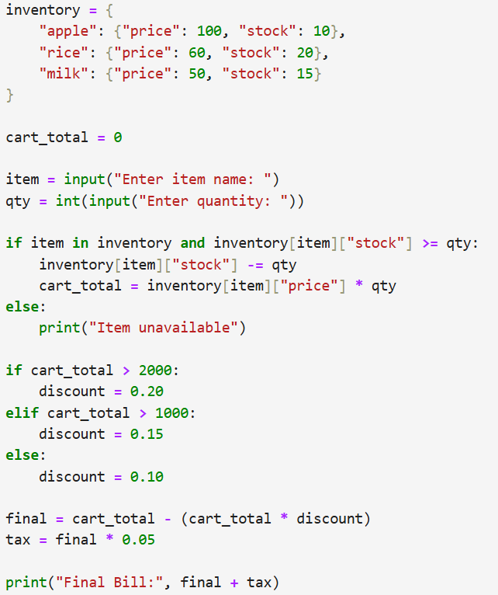
Output:
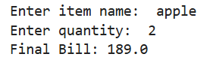
Q3. Student Grading with Subject Weightage
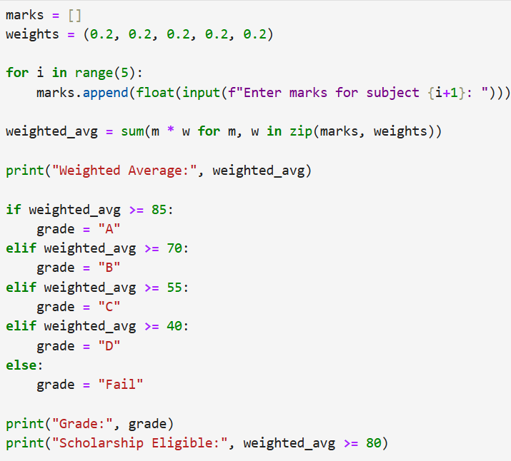
Output:
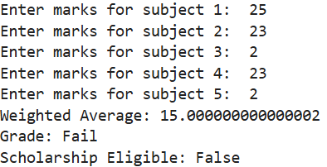
Q4. BMI + Health Recommendation
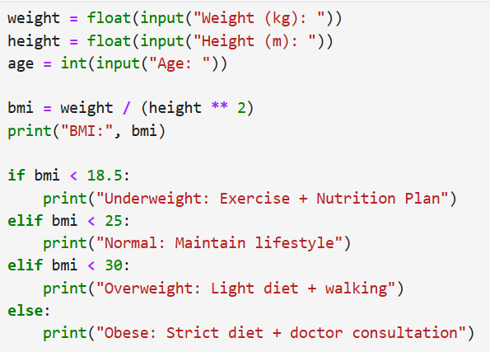
Output:
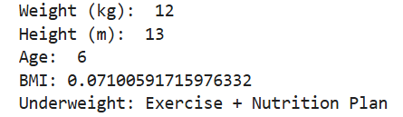
Q5. Telecom Prepaid Recharge System
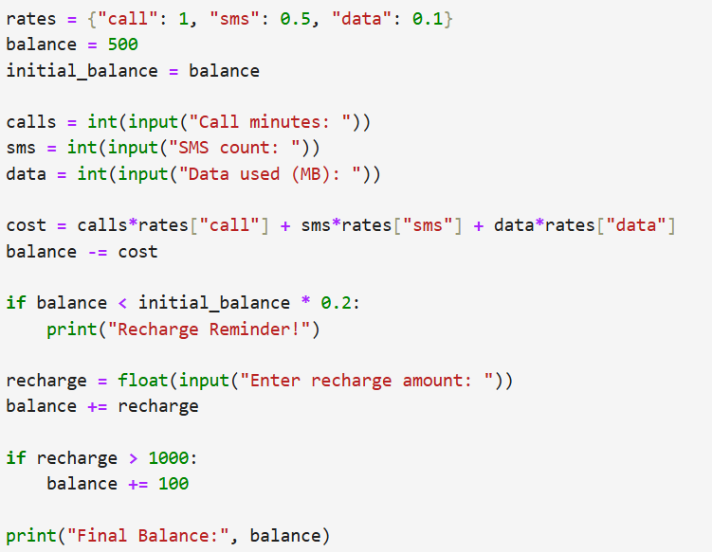
Output:
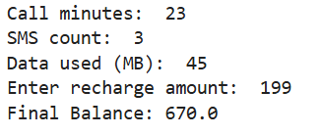
Q6. E-Commerce Discount Engine with Membership Levels
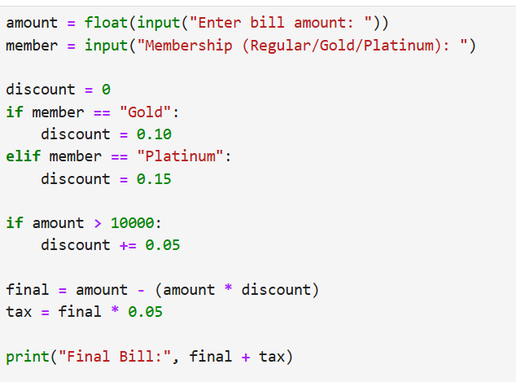
Output:
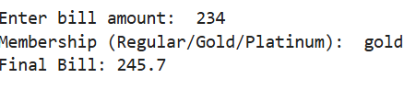
Q7. Hospital Emergency Unit with Multi-Condition Triage
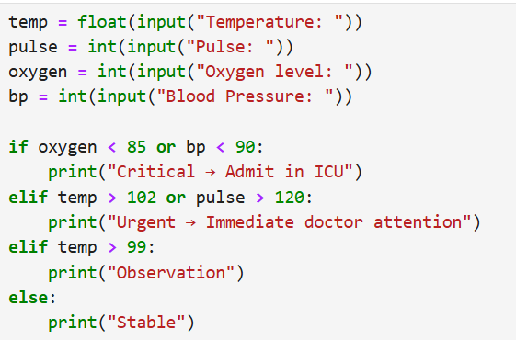
Output:
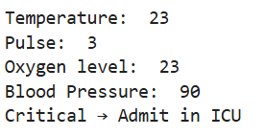
Q8. Online Examination Grader with Negative Marking
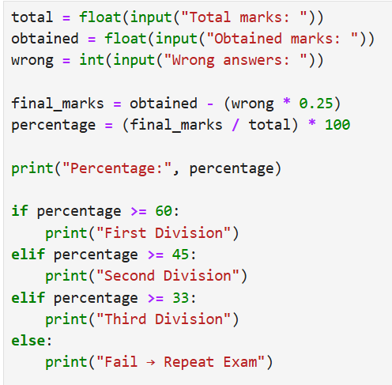
Output:
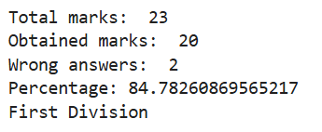
Q9. Movie Ticket Booking with Age & Timing Policy
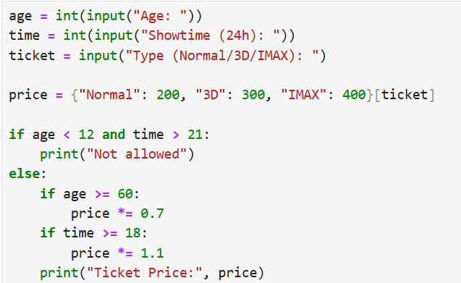
Output:
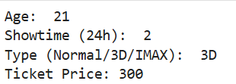
Q10. Weather-based Outfit + Travel Suggestion
”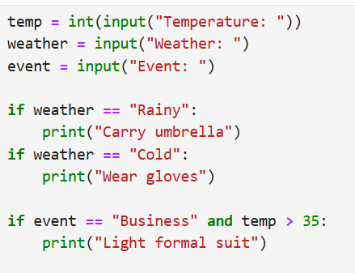
Output:
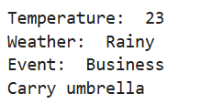
Q11. ATM Withdrawal with Note Counting + Receipt
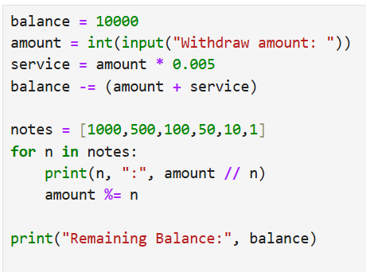
Output:
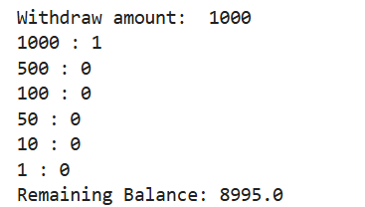
Q12. Library Fine Calculator with Membership Levels
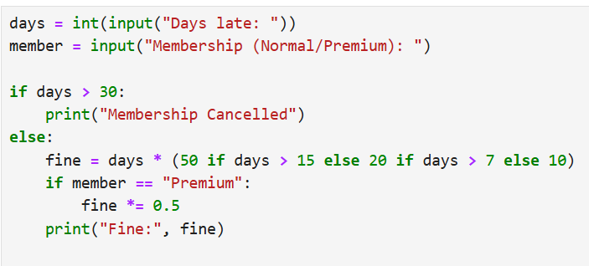
Output:
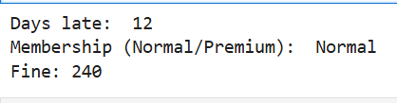
Q13. Sales Analysis Dashboard
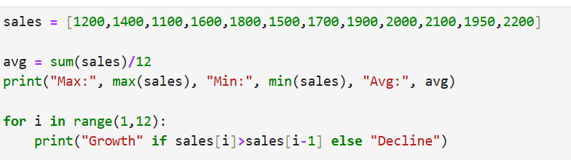
Output:
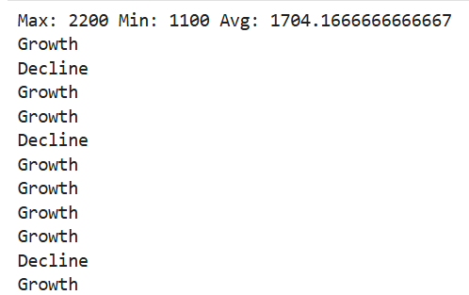
Q14. Multiplication Puzzle with Random Blanks
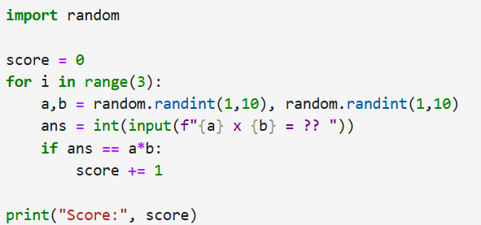
Output:
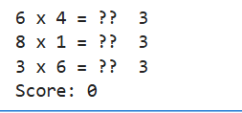
Q15. Password Strength + Re-entry Attempts
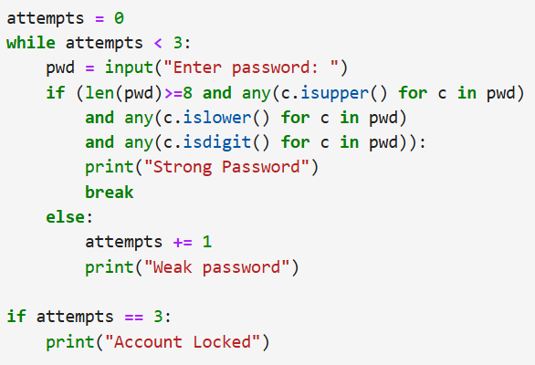
Output:
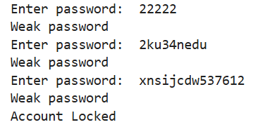
Q16. Electricity Bill with Slabs & Penalty
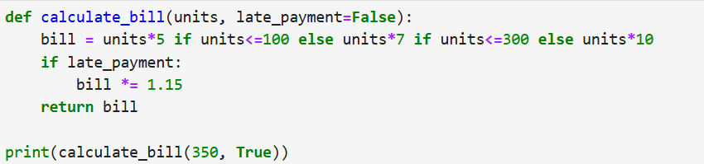
Output:
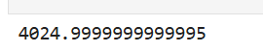
Q17. Cricket Match Predictor with Multiple Conditions
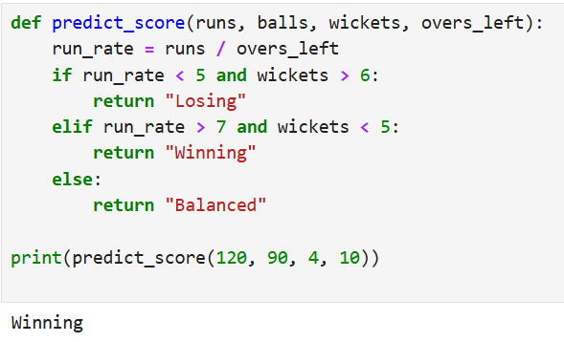
Q18. Hotel Booking with Tax & Discount
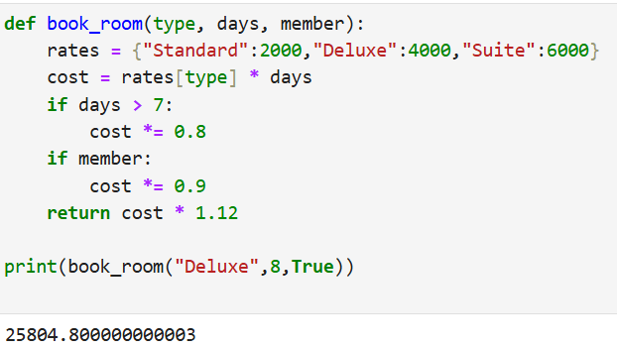
Q19. Flight Fare Calculator with International Tax
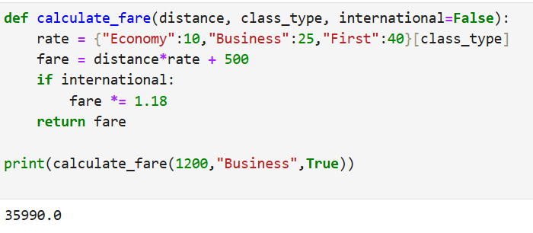
Q20. Smart Vending Machine with Wallet System
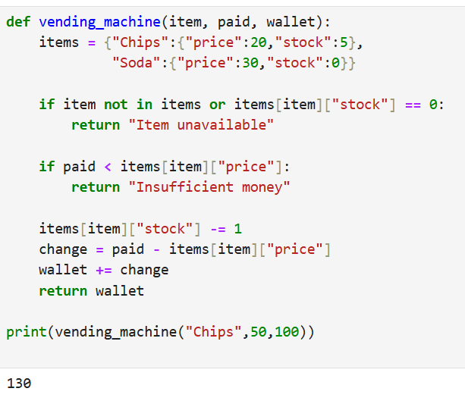
Lab 2
Program 01:
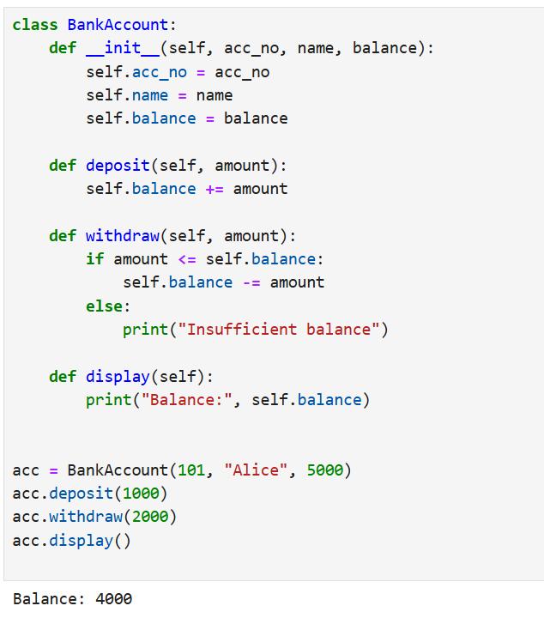
Program:
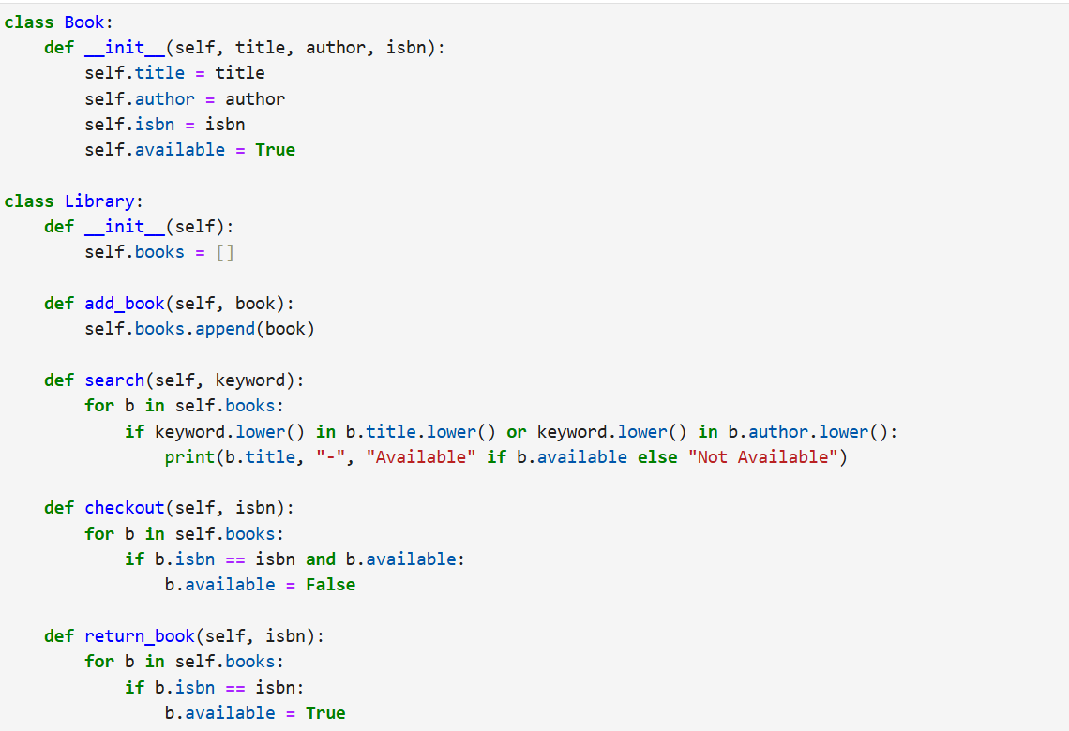
Program:
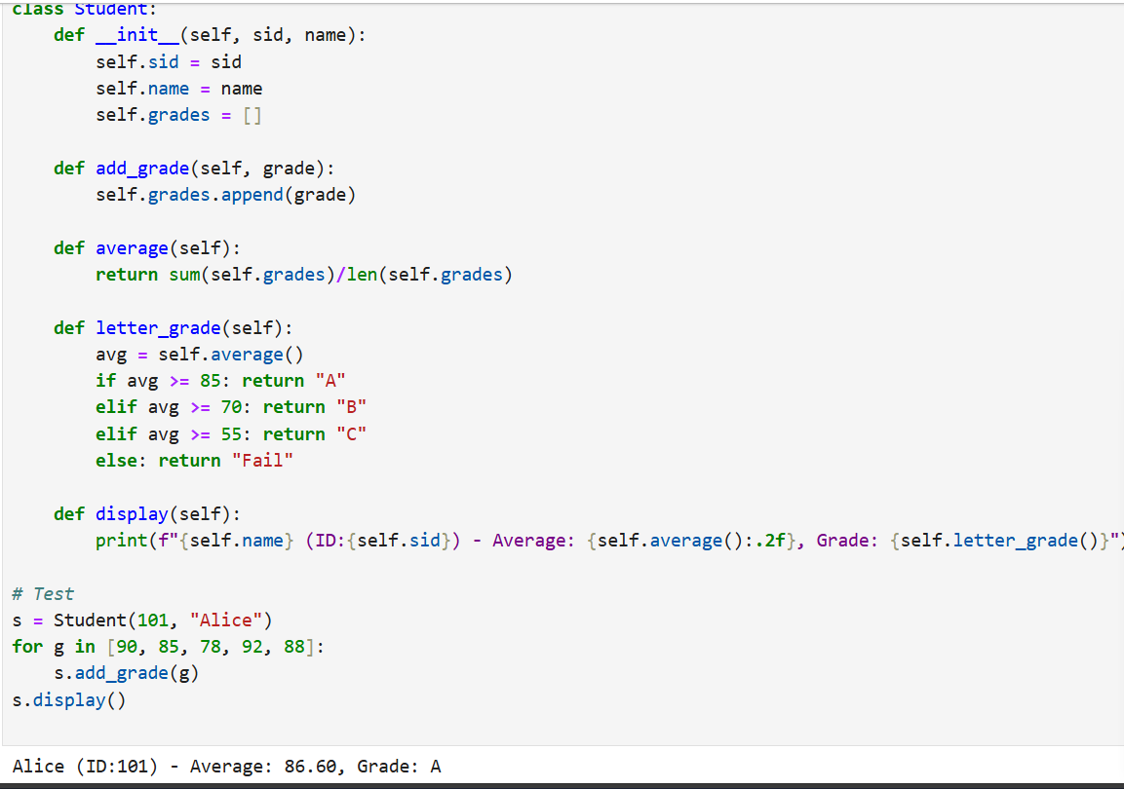
Program:
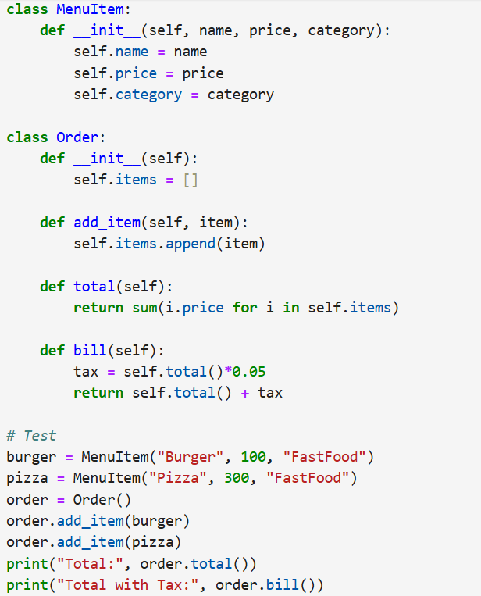
Output:
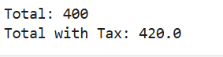
Program:
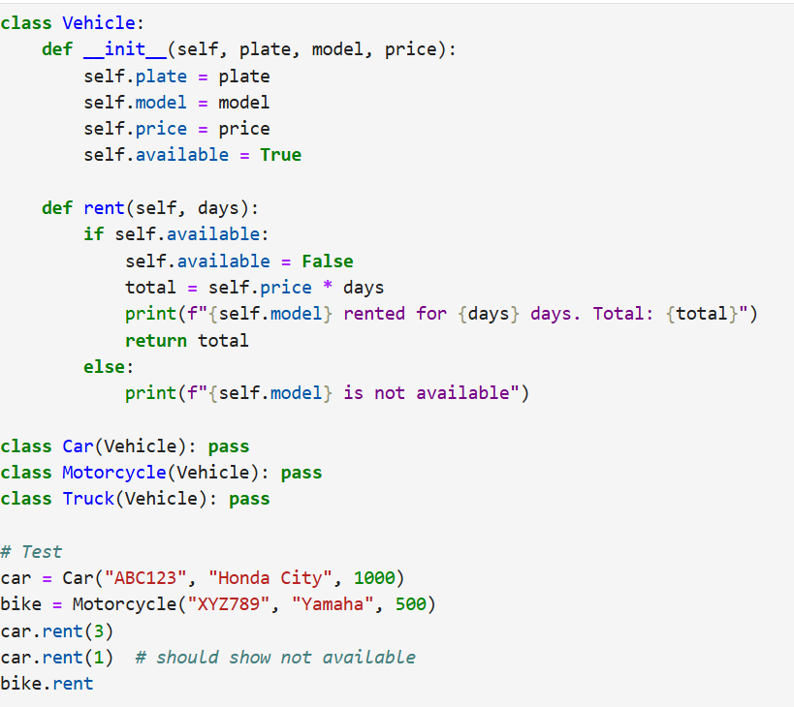
Output:
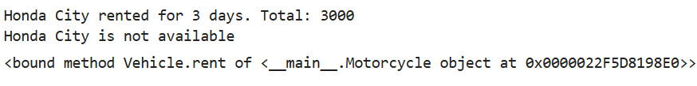
Program:
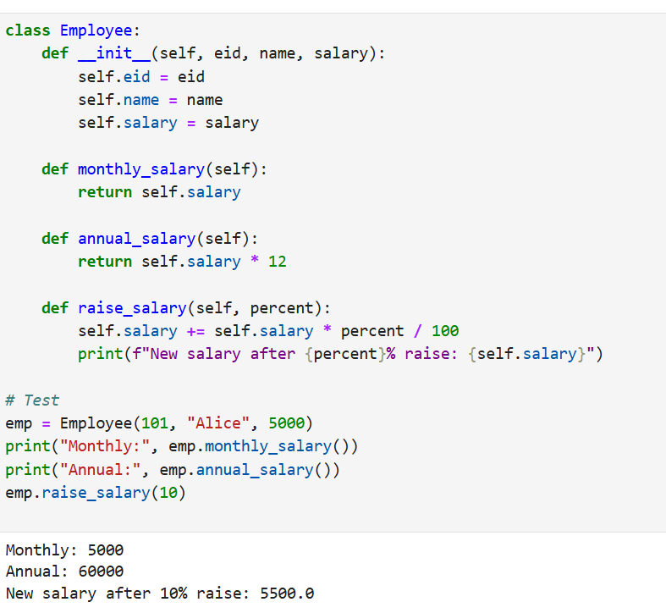
Program:
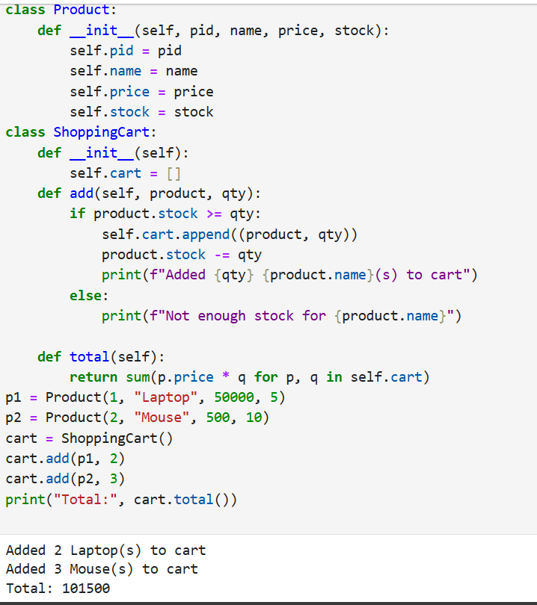
Program:
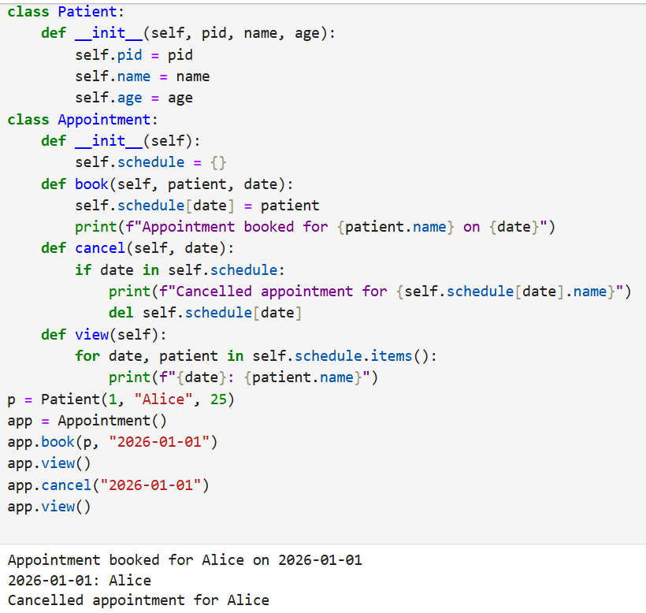
Program:
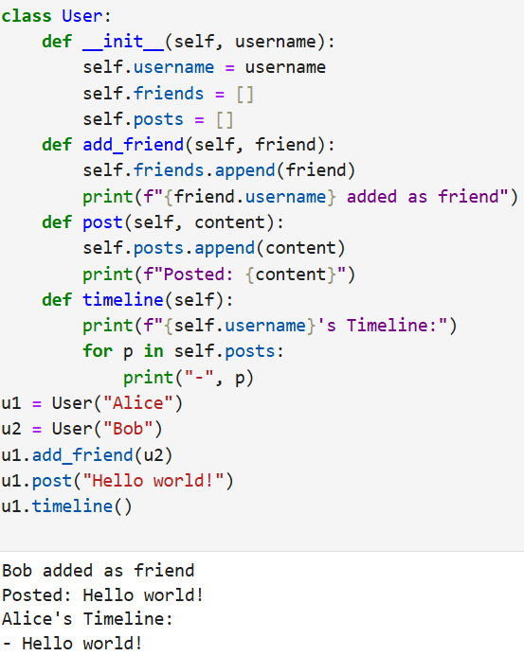
Program:
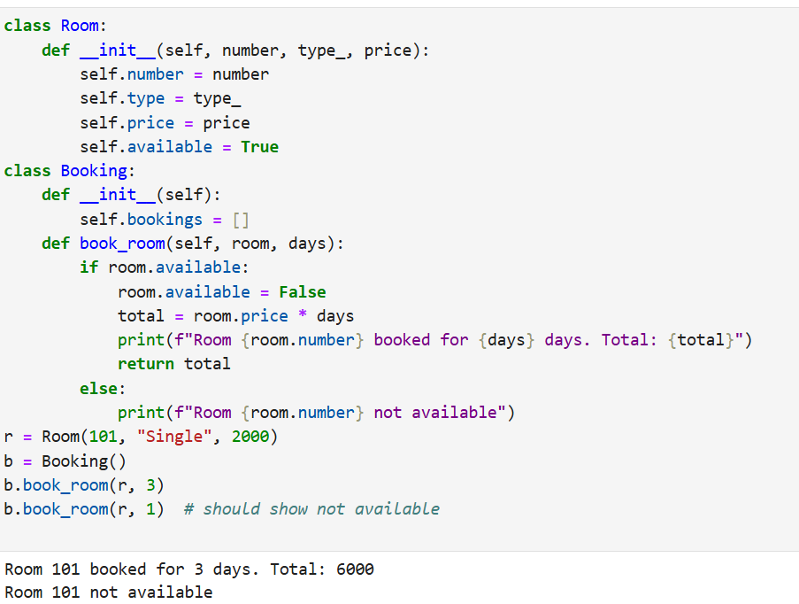
Program:
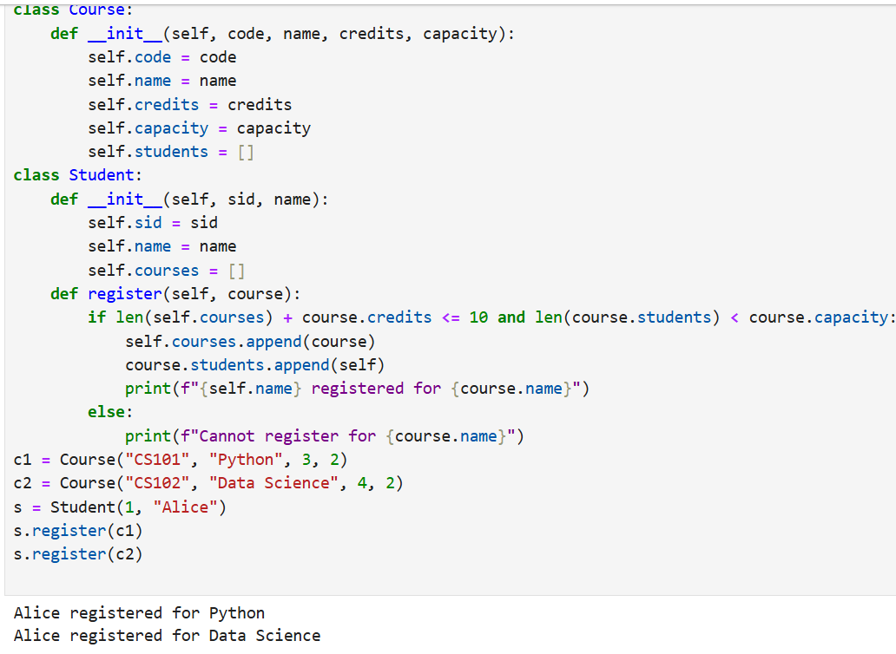
Program:
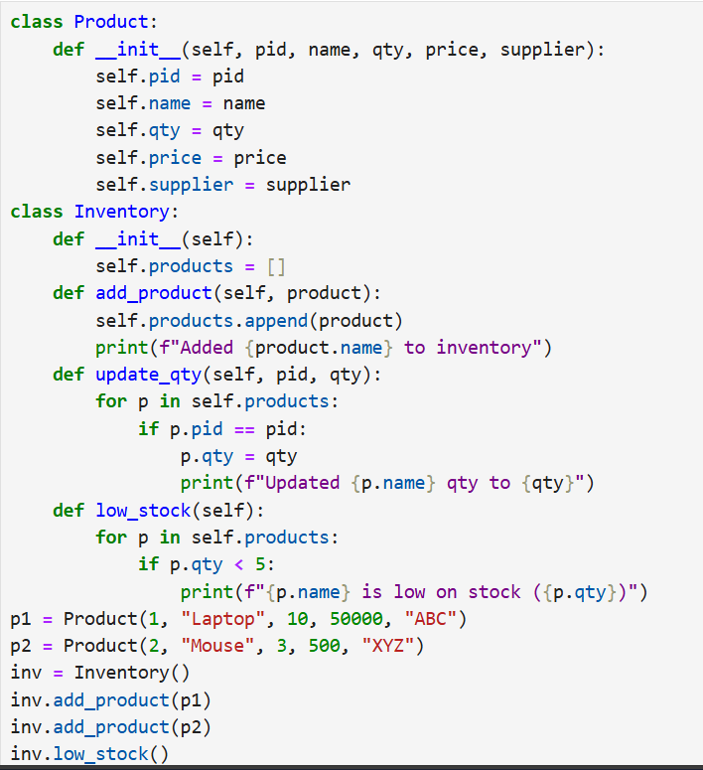
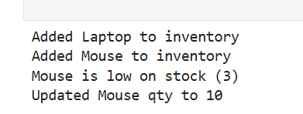
Program:
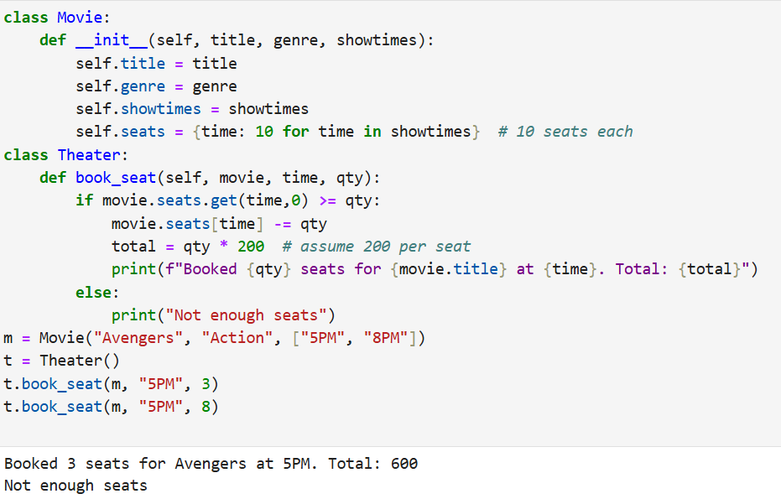
Program:
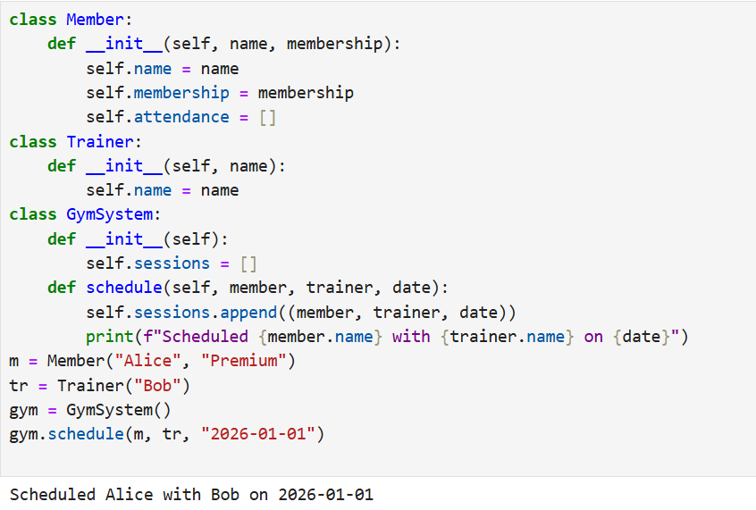
Program:
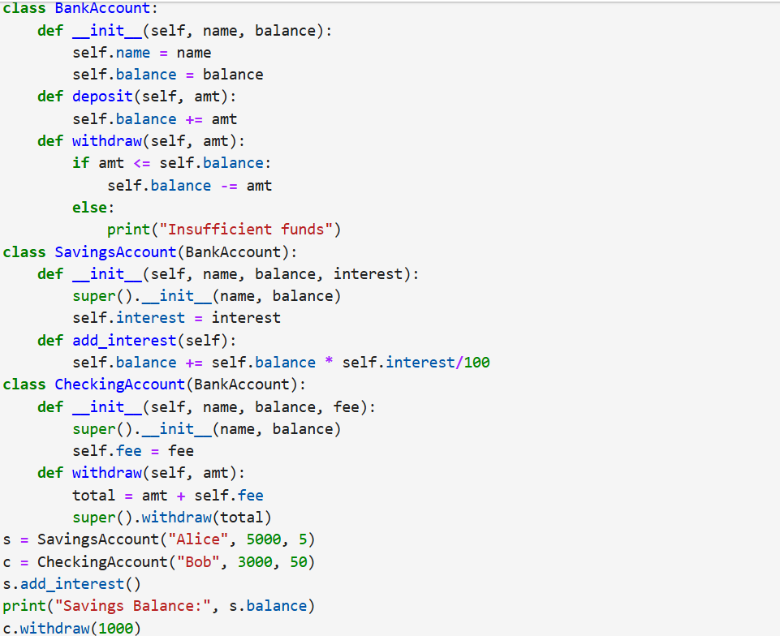
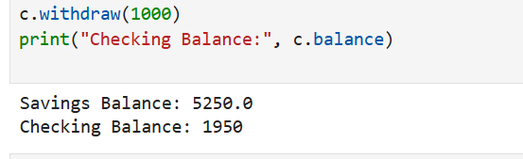
Program:
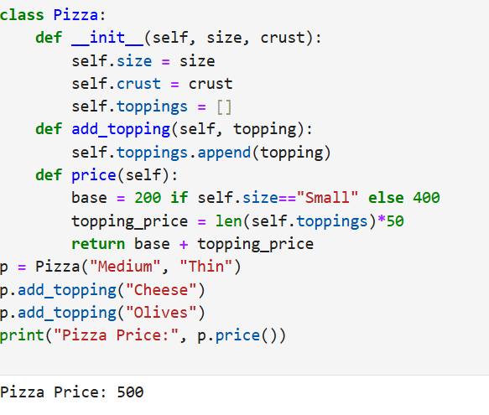
Program:
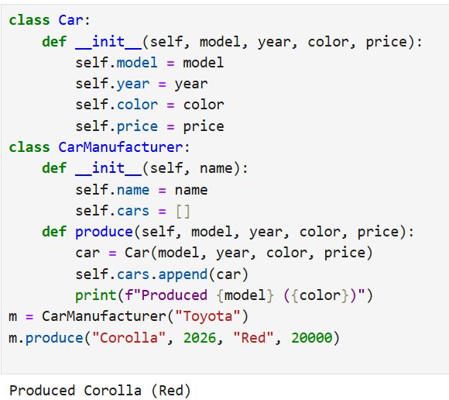
Program:
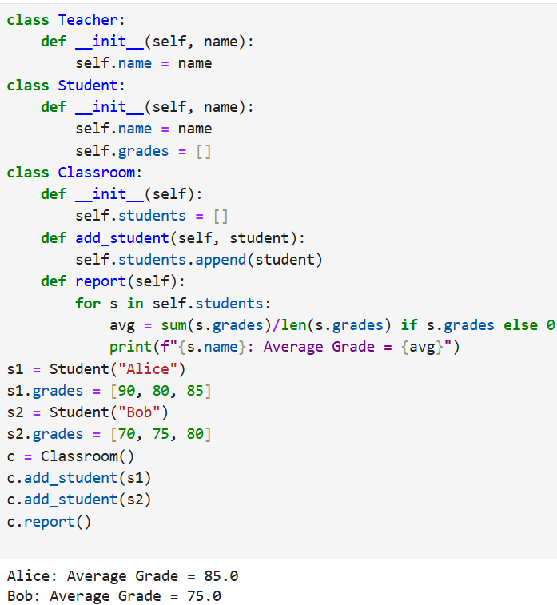
Program:
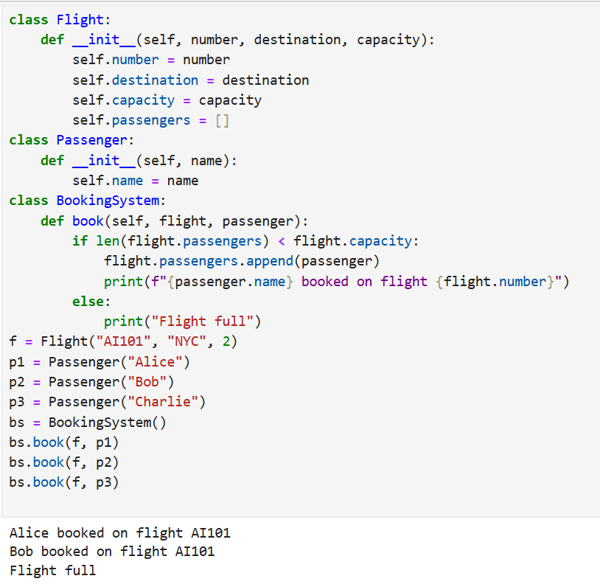
Lab 2
Question 1: A weather station records temperatures (°C) for 7 days
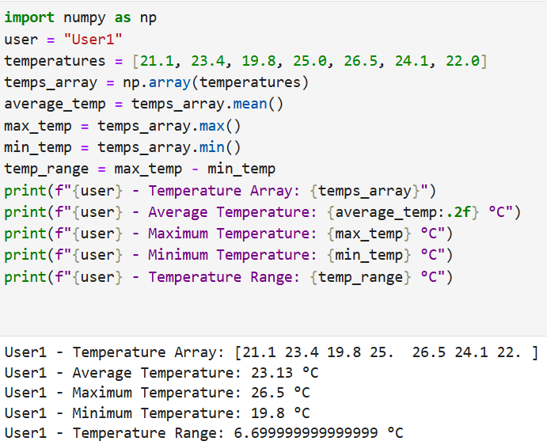
Question 2: A fruit store records daily sales of apples for 4 weeks:
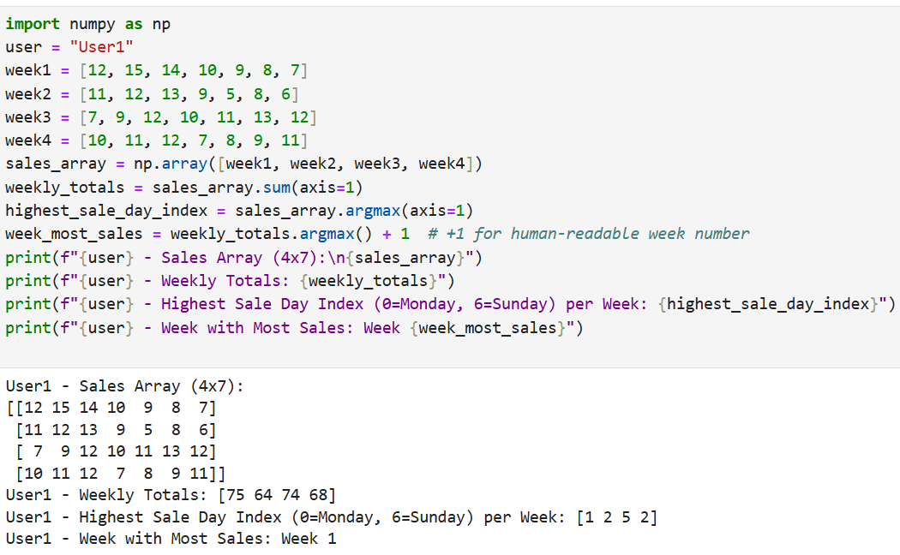

- Question 3: Students received marks in a test:
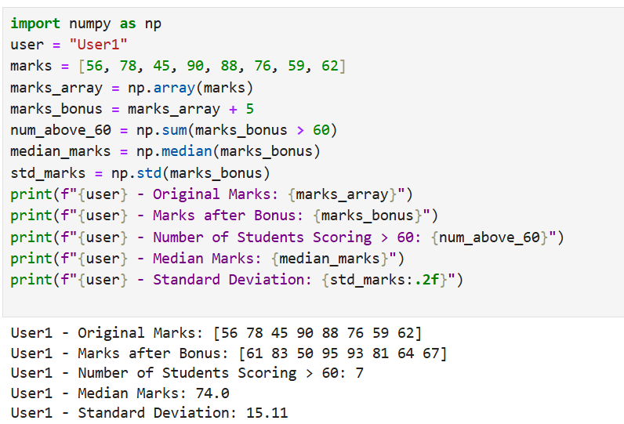
Question 4: A smartwatch stores daily step-counts for a user for 30 days.
Task:
- Generate a random NumPy array of shape (30,) with values between 2000–15000
- Reshape into a 5×6 matrix
- Find:
  - Weekly average steps
  - Day with maximum steps
  - Number of days user crossed 10,000 steps
Question 5: Heart rate readings (in BPM) for 10 patients recorded 4 times per day:
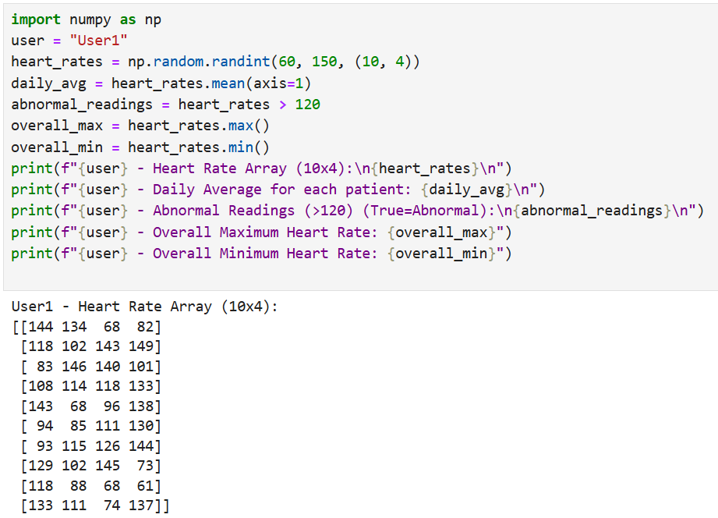
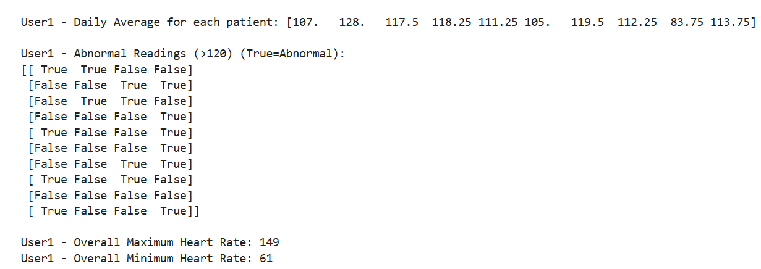Question 6: Two branches of a store record monthly sales (in thousands):
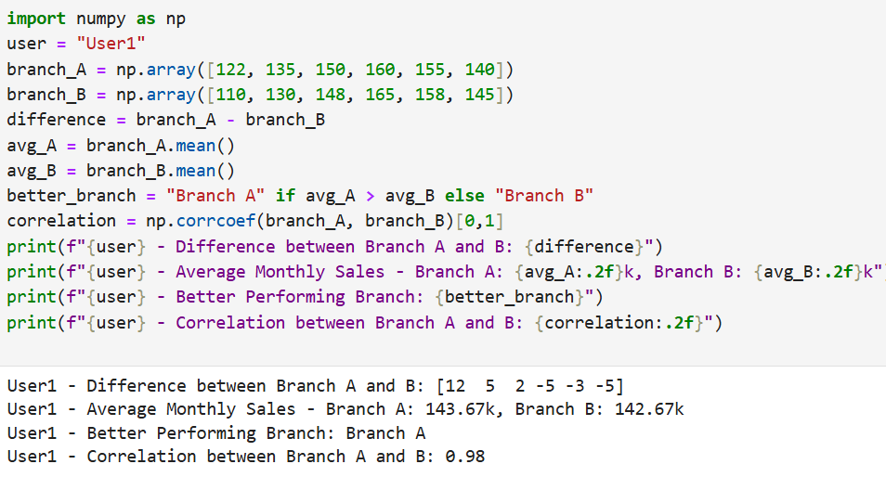
Question 7: Given a 4×4 grayscale image:
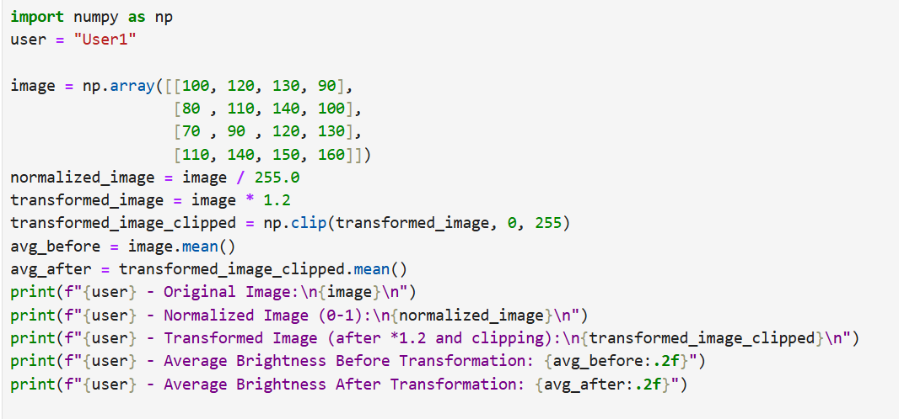
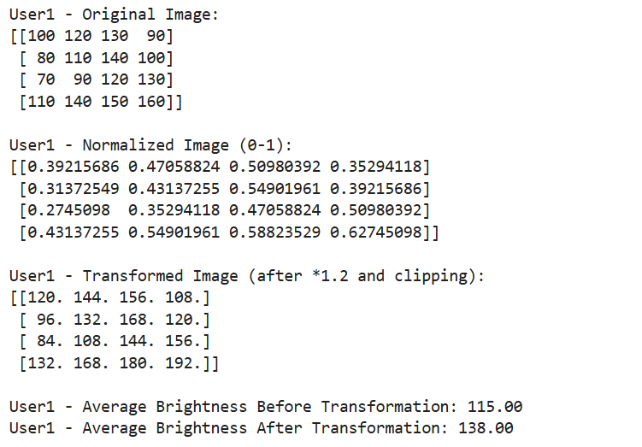
Question 8: Dataset contains 100 samples with 4 features each.
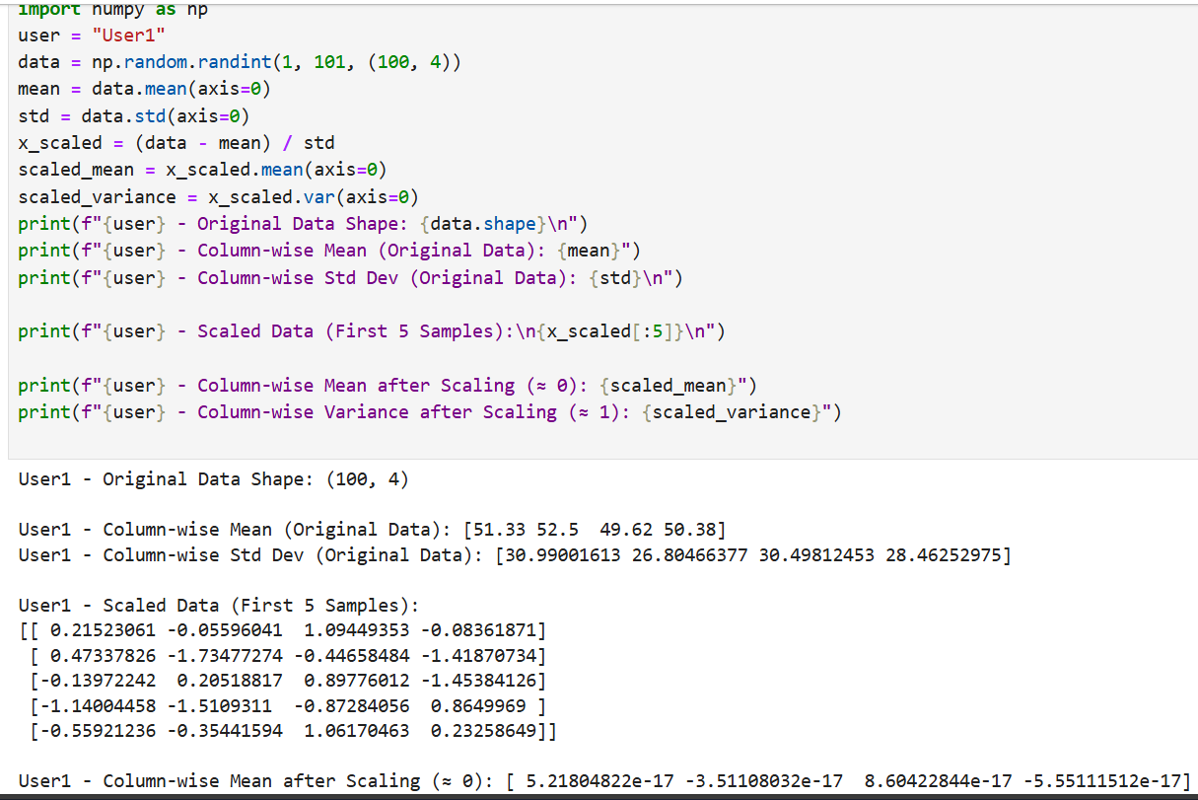Question 9: Simulate traffic density (cars per minute) recorded by 6 sensors over 24 hours.
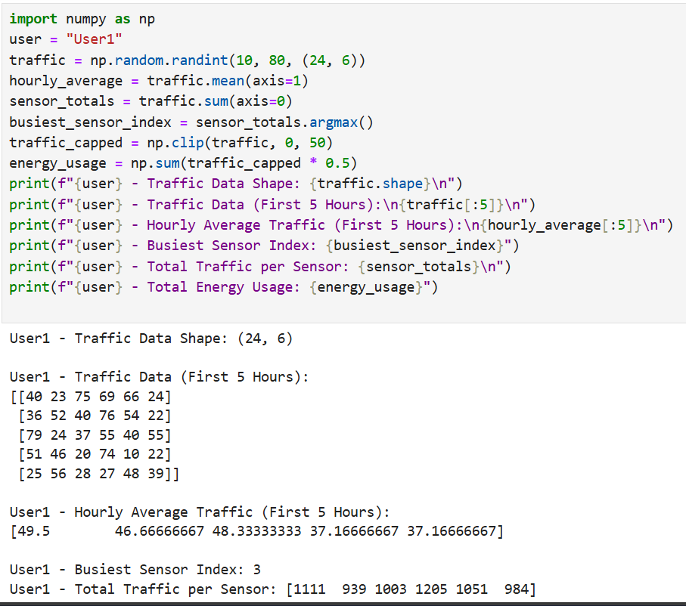
Question 10: You are simulating forces in a mechanical system.
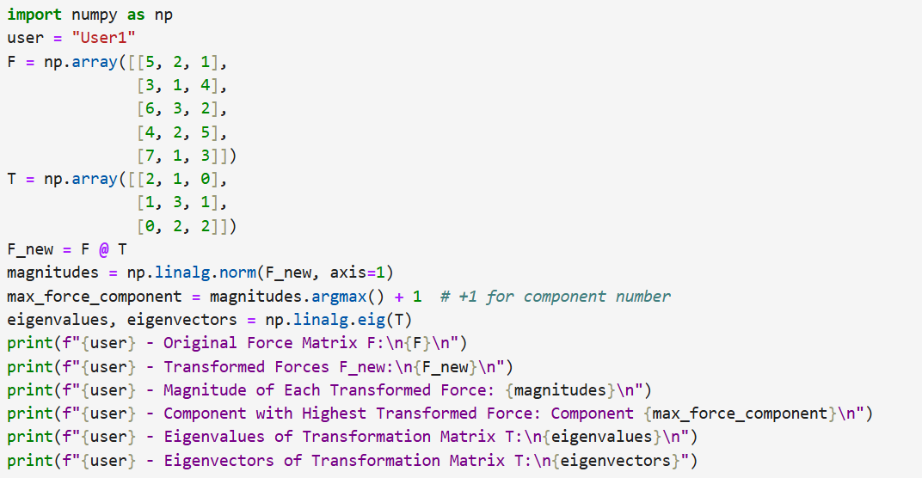
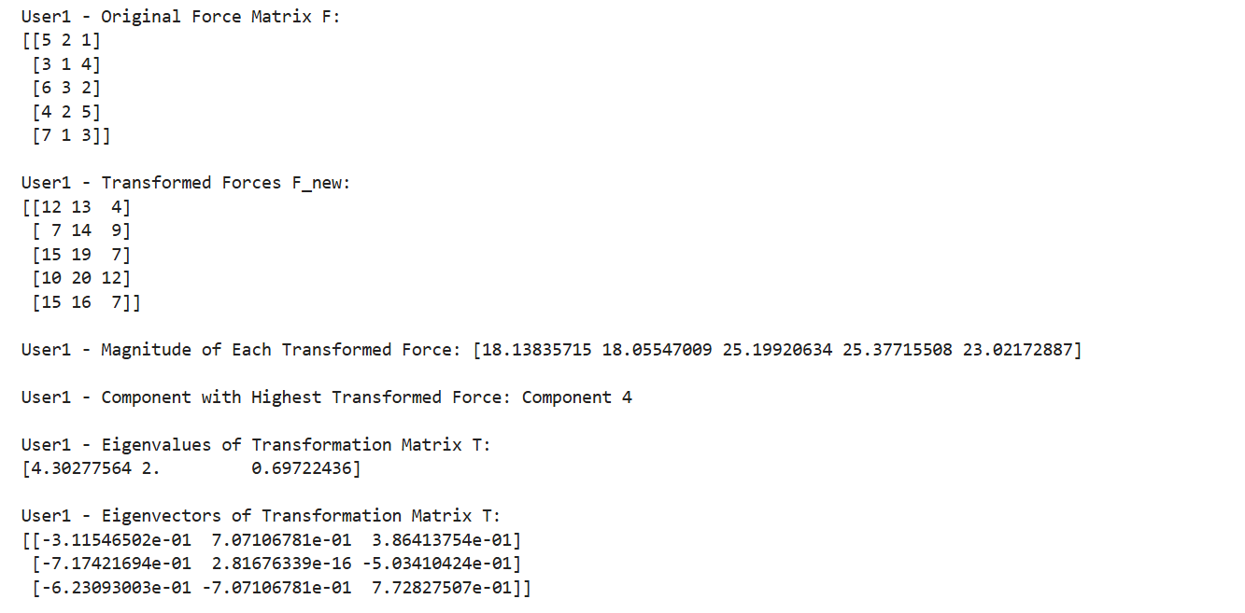

Lab 4
Q1. Patient Stay Analysis (Healthcare)
You are given a dataset containing age, disease_type, and hospital_stay_days.
Write a Python program using Seaborn to:
- Plot the distribution of hospital stay days
- Compare hospital stay across different disease types
- Identify which disease has the highest median stay
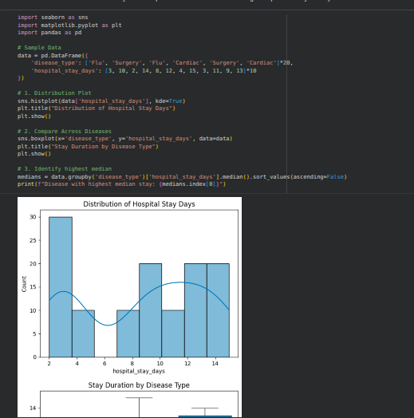
Q2. Sales Distribution Comparison (Business)
A retail dataset contains region and monthly_sales.
Write code to:
- Visualize sales distribution per region using Seaborn
- Detect regions with high sales variability
- Label the axes and add a title
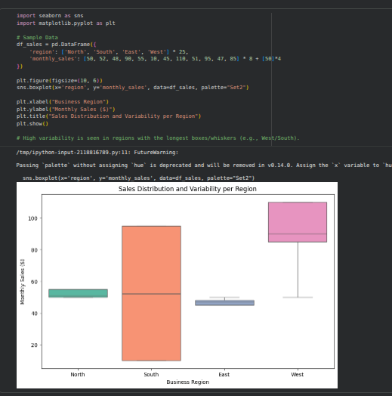
Q3. Student Performance Correlation (Education)
A dataset contains study_hours, attendance, and final_score.
Using Seaborn:
- Create a pair plot
- Plot a correlation heatmap
- Interpret which feature most affects the final score
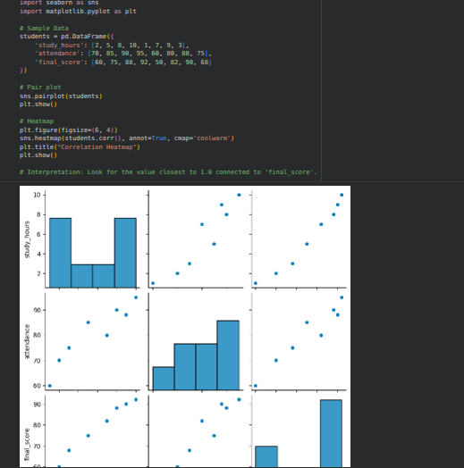
Q4. Customer Segmentation Visualization
Customer data includes age, annual_income, and spending_score.
Write a program to:
- Visualize relationships using Seaborn scatter plots
- Color-code points based on spending score
- Identify potential customer segments visually
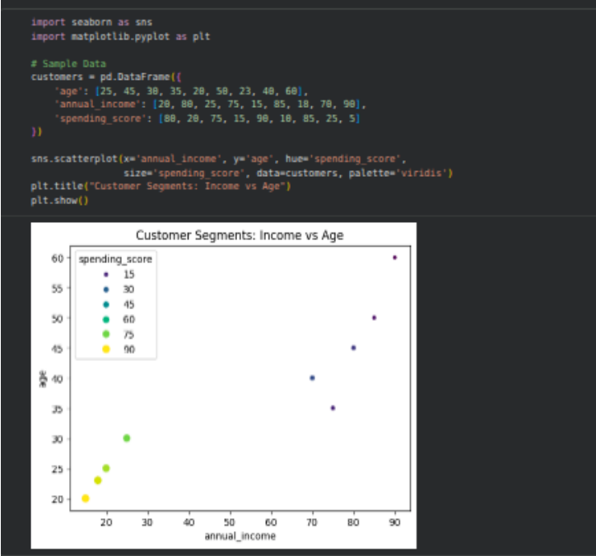

Q5. Model Result Visualization
You trained a classifier and obtained y_true and y_pred.
Write code using Seaborn to:
- Plot a confusion matrix heatmap
- Add annotations and color bar
- Clearly label predicted vs actual classes

